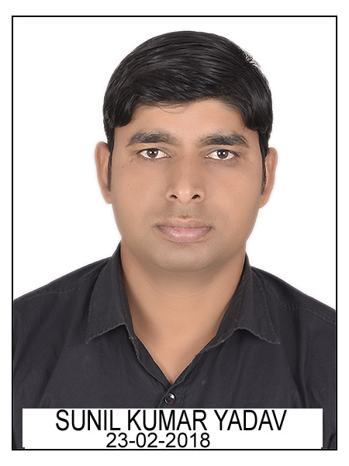
JECRC
Affix and Attest
passport
size photograph
JAIPUR

INDIVIDUAL TECHNICIAN DATA SHEET
Name of the Technical staff member | : | Sunil Kumar Yadav
Present Designation | : | Lab Instructor
Email Id: :1sunilkumar890@gmail.com
Contact Details :9166444055

I. Particulars of Educational Qualification: (only completed)

Category | Name of the Degree | Specialization | Year of Passing | Name of the College | Name of the University
ITI | ITI | Fitter | 2011 | BMITC | BTER

II. Academic Experience : 2 Year

III. Industrial Experience : 2 YEAR

